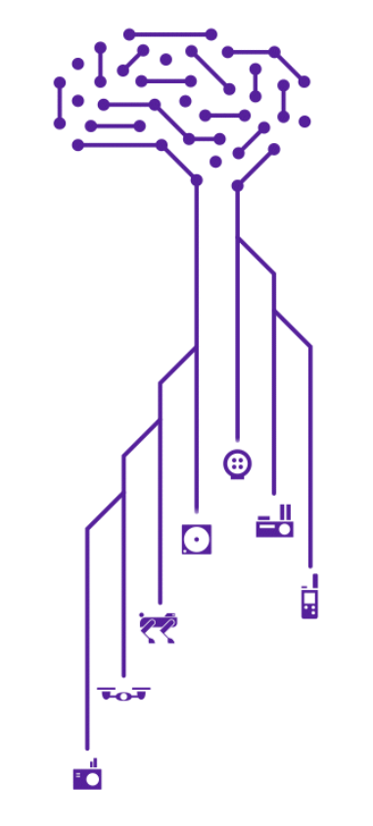

Kav AI — MVP v0.2
Repeatability, Scale, and Decision Context
Proving the consistency and economic impact of Kav AI.

Version: 0.2
Date: 2026-04-14
Author: Kav AI Development Team

1. Purpose
MVP v0.2 demonstrates that Kav AI is not a one-off detection tool, but a scalable system for identifying, prioritizing, and acting on integrity risks across an industrial facility.
This version moves beyond single-anomaly demos and establishes three core capabilities:
• Repeatability — consistent detection across many assets
• Scale — meaningful coverage of real facilities
• Actionability — clear prioritization and recommended next steps
---

2. What This MVP Proves
MVP v0.2 answers the key questions an operator will ask:

Can this system scale beyond a demo?
Yes — the platform processes thousands of assets and dozens of anomalies in a single run, not just isolated findings.

Does it help me decide what to do?
Yes — every high-priority anomaly includes recommended inspection actions tied to operational workflows.

Is the output meaningful to my business?
Yes — findings are connected to risk and economic impact, not just temperature differences.
---

3. System Output Overview

Facility Scan Summary
• Assets scanned: 1,200
• Thermal anomalies detected: 37
• High-priority anomalies: 8
• Coverage achieved: 65% of unit in a single deployment
This establishes that Kav AI can operate at facility-relevant scale, not just isolated inspection points.
---

4. Example Finding (Representative)
Asset: Insulated process piping
Observed condition:
• Surface temperature: ~120°F
• Ambient temperature: ~35°F
• ΔT: ~85°F
Secondary signal:
• Structural steel nearby shows ΔT ~49°F
Interpretation:
• Thermal signature consistent with insulation breakdown
• Elevated likelihood of Corrosion Under Insulation (CUI)
Recommended action:
• Prioritize this location for:
• Insulation removal
• Ultrasonic thickness (UT) inspection
This demonstrates the transition from detection → diagnosis → action.
---

5. Prioritization Output
Instead of a flat list of anomalies, MVP v0.2 produces a ranked inspection set:
• High-priority locations: 8
• Recommended timing: Next scheduled shutdown
Selection basis:
• Thermal severity
• Pattern consistency
• Cross-asset comparison
This ensures inspection teams know where to act first, not just what exists.
---

6. Coverage Context
A key limitation of early demos is lack of context around scale. MVP v0.2 explicitly shows:
• 65% of a process unit scanned in one day
• Coverage is repeatable and extendable across the facility
This reframes the system from:
• “interesting detection tool”
→ to - practical inspection coverage solution
---

7. Economic Impact Framing
Thermal anomalies are translated into business-relevant risk:
• Typical failure consequence (if unaddressed):
• $500K – $2M event risk (shutdown, repair, lost production)
• MVP scenario estimate:
• $750K – $1.5M avoided cost potential
This ties the output directly to business value.
---

8. Role of AI in MVP v0.2
A critical shift in this version is clarifying that:
> The drone and thermal camera collect data — > Kav AI is what makes that data usable at scale.
AI responsibilities in v0.2:
• Index and organize inspection data
• Detect anomalies across large datasets
• Rank findings by priority
• Enable retrieval across thousands of assets
Without this layer, the workflow does not scale beyond manual review.
---

9. Evolution from v0.1
MVP v0.2 directly addresses the limitations of earlier demonstrations:
Gap in v0.1 | Resolution in v0.2
Single anomaly demo | 37 anomalies across 1,200 assets
Detection only | Detection + recommended action
No scale context | Explicit coverage metrics (65%)
No economic link | Cost/risk framing added
AI unclear | AI positioned as scaling layer

---

10. Position in MVP Roadmap
MVP v0.2 is the second step in a staged evolution:
• v0.1 — Detection
Demonstrates anomaly identification
• v0.2 — Repeatability + Scale (current)
Demonstrates detection at facility scale
• v0.3 — Conversational Access
Contextual data chat in persona-tailored workspaces, with validated agent reliability
• v0.4 — Closed-loop Intelligence
Will connect detection → validation → action → feedback, with quantified inspection prioritization and RBI/IDMS workflow integration
---

11. Key Takeaway
MVP v0.2 proves that Kav AI is:
• Scalable — operates across hundreds to thousands of assets
• Repeatable — produces consistent findings, not one-off detections
• Actionable — outputs prioritized inspection decisions
• Relevant — connects technical signals to financial impact
It moves the system from:
> “We found something interesting”
to:
> “Here are the 8 places you should inspect next — and why.”
---

